Get inspired from jP Morgan

Fusion

DataQuery

<https://fusion.jpmorgan.com/solutions/containerized-data>

<https://www.talentify.io/job/cre-data-domain-architect-vp-seattle-washington-jp-morgan-210449207>

<https://www.talentify.io/job/wealth-management-data-domain-architect-senior-associate-new-york-new-york-jp-morgan-210470111>

*We have found the Fusion platform to provide a stable, modern and reliable way to connect into the J.P. Morgan's Securities Services data universe. We were able to establish secure connectivity between Fusion and our proprietary code base within hours. Storebrand is looking forward to expanding the use of Fusion as the platform extends to new areas.*

**Fusion is a cloud-native data solution for institutional investors, providing end-to-end data management, analytics, and reporting across the investment lifecycle.**Seamlessly integrate and combine data from multiple sources into a single data model that delivers the benefits of scale and reduced costs, along with the ability to more easily unlock timely analysis and insights

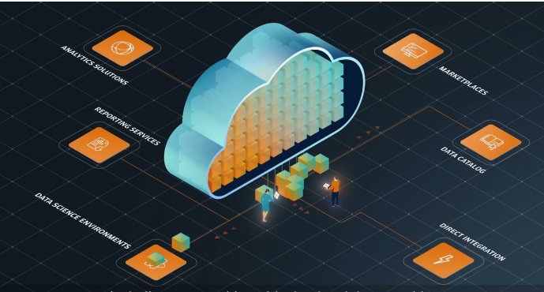

Our next generation cloud data platform that delivers data management and reporting solutions across the investment lifecycle.

Fusion will gather and integrate data from multiple sources, and combine it into a common data representation, ready to be consumed anywhere, anytime, and in any format, without additional data preparation.

The new data catalog enables you to easily discover data that is immediately usable, by connecting to the platform’s modern APIs.

Fusion supports an open architecture, with flexible distribution partnerships with cloud and data providers, all managed by J.P. Morgan data experts.

Improve decision-making and gain efficiencies, with expanded access to the data you need at the highest quality and consistency you expect,

while reducing the cost to organize and manage that data. Discover a unified data experience with Fusion

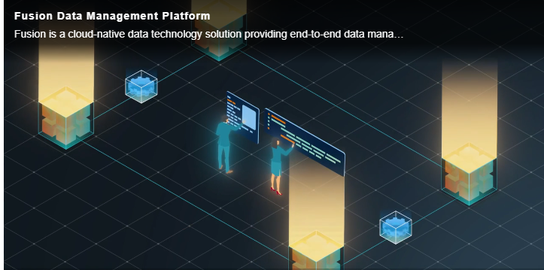

Data Catalog

Data is everywhere, but that doesn't mean it's easy to find. Fusion's data catalog provides access to a diverse range of data feeds, making it easier for you to access the data you need. Proprietary and third-party data products are centralized and easily searchable, making it easy to browse for data by asset class coverage, investment theme or provider.

